**Project Design Phase –II**

**Data Flow Diagram &User Stories**

|  |  |
| --- | --- |
| Date | 03 October 2022 |
| Team ID | PNT2022TMID50061 |
| Project Name | Real Time River Quality Monitoring And Control System |
| Maximum Mark | **4** Marks |

**Data Flow Diagram:**

The Data Flow Diagram(DFD)Of The Monitoring Control System in the diagram with other real time environmental information for monitoring.

**Example**

**Flow Diagram:** 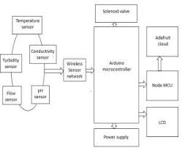  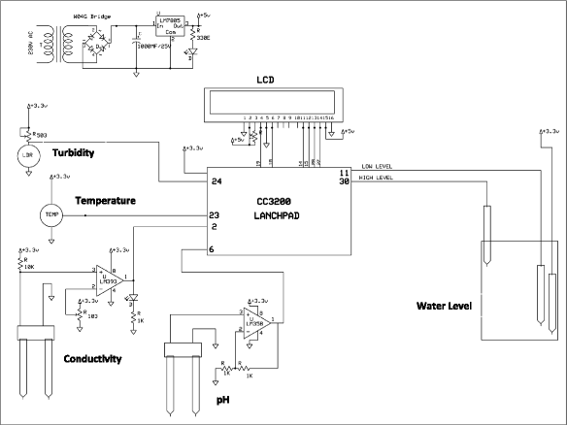

1)Ensuring the safety of water is a challenge due the excussive soruce of pollutants,most of which are man made.

2)The main course of water quality problems are over exploitation of natural resoruces.

3)This system is also include on alert facility,to inform the user ofdivistion of water quality parameter.

4)Solar enable distributeted.

**User Stories**

Use the below template to list all the user stories for the product.

|  |  |  |  |  |  |  |
| --- | --- | --- | --- | --- | --- | --- |
| **User Type** | **Funtional**  **Requirment(epic)** | **User Stories Number** | **User story**  **/task** | **Acceptance creteria** | **priority** | **Release** |
| Hardware Design | Control Surface | USN-1 | AS a user ,utilized core person | This system several sensor very time consuming | Reduce the air polution | System with a monotous process. |
| PH sensor | Thing useful constant to diplay effect on the author. | USN-2 | Hydrongen ion density in a bleach. | Ph value process the solubility of element and componends | pH=-log{H=} | It consist of value 0-14pH. |
| Parameter monitring | Us environmental production agency | USN-3 | AS a user ,water is a one of the most important facter | Monitoring and detecting change in the water monitoring including turbidity | Feasible to infer the water quality | Amount of the impurityin the water. |
| Application | Domestic water is indeted drinking and cooking purpose | USN-4 | As a user,acceptable limits of substance such as aluminium. | Efficience to availability real time information | Data collect at the apart site can be displayed in visual formar. | System will immense help high frequency . |
| Software Design | WSN used for a sysytem | USN-5 | IOT platfrom | Natural network models in big data | Big data analytic |  |